Week Eight Report
Tic Tac Toe

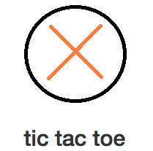

159.356 Software Engineering Capstone Project 2013
Massey University

Group 2
Max Dietrich
Ryan Murphy
Sarsha Jones
Jesse Voight
Luke Christiansen
Jason Rurunanra

Table of Contents

1.0 Process......................................................................................................................3
1.1 Project Plan Modifications...............................................................................3
1.2 Task Documentation........................................................................................4
1.3 Architecture/High Level Design.......................................................................4
1.4 Usage of Project Infrastructure........................................................................5
1.4.1 Issues....................................................................................................5
1.4.2 Repository.............................................................................................5
2.0 Quality Assurance......................................................................................................6
2.1 Automated Regression Testing........................................................................6
2.2 Other Quality Assurance..................................................................................7
3.0 Product.......................................................................................................................7
Appendix 1: Feature Implementation List...........................................................................10
Appendix 2: Use Case Diagrams.......................................................................................11
1.1 Social Network Login.....................................................................................11
1.2 Friend Management......................................................................................12
Appendix 2: Class Diagram...............................................................................................13

1.0 Process

1.1 Project Plan Modifications
The project plan has been updated as follows:
Schedule
- Rather than producing prototypes in weeks 6, 9 and 12, the prototypes will be produced in weeks 8 and 12 in order to coincide with the required prototype presentations for the project.
- The ability for players to add and delete friends has been included in the week 8 prototype.
- The ability to create and join private games has been pushed to the final prototype, with only public games being implemented in the week 8 prototype.
- Facebook login has been brought forward to the week 8 prototype, while Google login will be in the week 11 prototype.
- Initial tests have been added to the week 8 prototype. These include both internal logic testing (white-box testing), server tests (black-box testing), and browser/compatibility tests.
- The final prototype will implement the ability for players to write their own bots, private games, and the recording of games.
- The finalized user interface will also be implemented in the final prototype due to a lack of contact from the team member responsible for that task. It is anticipated that this task will need to be reassigned to another team member.
- The final prototype is being planned for week 11. This is to keep the project on track and provide a buffer zone.
Monitoring and Controlling Mechanisms
- Rather than having twice weekly meetings, the team will instead meet before or after the meeting with Russell at the start of the week. In order to keep the project on track, there will also be at least one team coding session a week where the team can review its progress, address issues, and work together to get features implemented.
Methods, Tools, and Techniques
- Clarified that JSON and jQuery will be used to communicate the game state between the client and server.
- Added that the Bootstrap framework will be used in the creation of the user interface.

The Project Plan can be located at https://github.com/mbdietrich/MUCapstone2013_Team2/blob/master/CapstoneProject/docs/Project%20Plan%20v2.doc

1.2 Task Documentation
The live feature implementation list for the project can be found at: https://github.com/mbdietrich/MUCapstone2013_Team2/blob/master/CapstoneProject/docs/Feature%20List.xls

In addition, the feature implementation list as it stands of the writing of this document is included as Appendix 1.

This list details the project features, the team member responsible for implementing them, and the planned, anticipated, and actual date of completion. This provides the team with a plan to follow and shows how the team is progressing as compared to what is planned.

1.3 Architecture/High Level Design
The architecture of the project remains the same as it did for the first prototype. Additional use case diagrams for the friend management features and Facebook/Google login that have been implemented in the week eight prototype are included in Appendix 1

An updated class diagram is included in Appendix 2 that shows the additional features and changes that have been implemented since the first prototype.

The interface between the client and server is undertaken through the use of jsp files on the client size and Java servlets on the server side.

Outside of the game itself, players, on the client side, communicate with the server through POST requests to the servlets. Details, such as the player’s name, are extracted as parameters from the POST requests and then processed on the server side.

Communication from the servlets back to the jsp files is done by way of query strings which are included as part of the URL. This information is then extracted and used by the jsp file to build the HTML code for the page.

In terms of the game itself, the jsp file regularly polls the servlet requesting the game state data which is sent in JSON format and parsed using jQuery. When a player makes a move, this information is sent from the jsp file to the servlet as a POST request.

1.4 Usage of Project Infrastructure
1.4.1 Issues
The issue tracking system on GitHub, where the project repository is based, is used by the team to record issues. Since the inception of the project 30 issues have been opened, of which 3 remain open at the time of writing.
Breaking down these issues, 2 are recorded as required feature enhancements, 4 as invalid implementations or results, and the rest as code bugs. As the team uses the issue tracking system in a broad sense, recording details that need to be completed in order to fully implement a given feature that has been partially implemented, the non-labeling of the other issues is a reflection of this use of the issue tracking system.

In terms of number of issues opened, Luke has opened 16, Max 13, and Jesse 1. This reflects that fact that Ryan has predominantly been working on the logic tests, while Sarsha has been working on the server tests which Max has been overseeing and so he has been opening the relevant issues. Jesse has also been working closely with Max on server side features, with Max opening the relevant issues. Luke has been working on client side features and so has been opening issues relating to that. Jason has not been involved in any of the programming, with the exception of basic user interface assets for the week 4 and 8 prototype.

Where issues relate to a feature that has been assigned to a team member, the issue may be assigned to that person, however, given the relatively small number of issues, and that each team member takes responsibility for keeping up to date on open issues, there has been no negative impact of leaving issues unassigned as they tend to be quickly closed.

1.4.2
Repository
No real branching has occurred in the repository, other than for the week 4 prototype. This is a result of the team’s feature-driven approach to the project. The features tend not to interfere with each other, and once a feature is implemented it is made stable. As such, all work is able to be undertaken on the master branch. Similarly, because the team has been focused on implementing features, no spikes have been undertaken that would necessitate the branching of the repository.

In terms of commits, over the past month Luke has done 35 commits, Max has done 23, Ryan has done 9, Sarsha and Jesse have done 5 each, and Jason has done 3. All commits have comments.

The number of commits dropped during the end of August/beginning of September. This was a result of the mid-semester break and the delay in some team members attending meetings and progressing on the project after returning from the break. Generally, all team members are now on track and are attending meetings and commits for the past week have returned to the same levels they were at before the break.

2.0 Quality Assurance
2.1 Automated Regression Testing
Game Logic Tests
Game logic testing is undertaken using a white-box technique. This technique was selected as it is the most appropriate for testing the internal structure and working of the game. This ensures that only the game logic is testing, without interference from the user interface or the client/server architecture.

The game logic tests created are:
- GameBotTest
This tests the validity of the default bot, ensuring that it can select legal moves, can complete a game without crashing, and can get it’s own name for display.
- SubGameTest
This test checks to ensure that the methods of the subgame class operate correctly. It checks that placing and getting a piece is accurate, that getting and setting a board is accurate, and that getting and setting the status (winner, loser, open, closed) of a board is accurate.
- GameStateTest
This test checks the accuracy of the game state methods. It checks that placing a piece is accurate, that finding and getting a winner is accurate, that getting the state and status of the subboards and main board is accurate, and that getting the current player accurate.

- GameSessionTest
This test checks that getting the current game is accurate, that you can join a game, that making moves is accurate, that you can find out whether a game is open (is able to be played on), that getting the player number of a player is accurate, and that leaving a game works.
- GameRulesTest
This test checks to ensure that each of the possible ways to win a game result in a win.

Server Tests
Server testing is undertaken using a white-box technique. This technique was selected as it allows for the simple testing of specific server functions using knowledge of how the client will interact with the server and the responses that are expected. All valid HTTP requests are documented in a file, Requests.txt; the server tests test each request on that list.

2.2 Other Quality Assurance
Some minor browser and compatibility testing has been undertaken. Rather than formal testing, this is done as features are implemented where the team tests their workings on Chrome, Firefox and Safari on both Windows and OS X. More comprehensive browser and compatibility testing will be undertaken in the future.

3.0 Product
A class diagram for the first prototype is included as Appendix 3.

The prototype can be built and run using NetBeans. It then runs using the Tomcat server. Alternatively, the project is regularly uploaded to a server and can be accessed at http://capstoneg2.jelastic.servint.net/CapstoneProject/

The .war file for the Week 8 Prototype is also available for download here:

https://github.com/mbdietrich/MUCapstone2013_Team2/releases/tag/v0.2

Web Site
Description:
The web site consists of a login screen where a player can log in with a username and password. There is also a link to a registration page if a player has not previously registered.

There is also a Facebook button where a player can give permission for the site to access their Facebook account. If a user has previously granted Facebook access to the site, they will be automatically logged in. On first login using Facebook, players are given the option to link their Facebook account to a new or existing account with the site.

After logging in, players can access the “lobby” where they can initiate a public game against the default bot or another player.

Players also have access to a profile management page where they can change their personal details, send/accept friend requests, view their friends, and delete friends.
Files:
accountManagement.jsp, channel.html, fblogin.jsp, game.jsp, index.jsp, lobby.jsp, jquery-1.8.3.js, lobby.jsp, logout.jsp

Server
Description:
The server handles the communication between the client and the game. It manages the creation of games, the joining of players, the making of moves, and the sending of the game state to the client. At this stage player vs. bot and open player vs. player games are supported. The server also handles profile and friend management, and access to the database.
Files:
Encryption.java, FacebookManager.java, FriendManager.java, GameCreate.java, GameJoin.java, GameManager.java, GameStateGet.java, GetPublicGames.java, JSONBuilder.java, Leave.java, MakeMove.java, PlayerJoin.java, ProfileManager.java, RemotePlayer.java, SessionCleanupService.java, databaseAccess.java

Player
Description:
The player files handle the storing of player and bot information. At this stage only a “dumb” bot exists that makes valid moves, but which makes no attempt at winning a game.
Files:
Bot.java, GameBot.java, Player.java.

Game
Description:
The game files store the state of games, the rules, and ensure that only valid moves can be made. At this stage subgames may still be played in provided the subgame has not been won and that there are still positions available to play; that is, subgames are not ended at the point at which a draw is inevitable.
Files:
Coordinates.java, GameRules.java, GameSession.java, GameState.java, IllegalGameException.java, SubGame.java.

Appendix 1: Feature Implementation List

Tic Tac Toe - Group 2, Feature List | updated 19/9/13
Feature | Assigned to | Estimated completion date
game state | Max | completed
game rules | Sarsha, Ryan, Luke | completed
game session | Max, Jesse | completed
default bot | Ryan | completed
initial web site | Jesse, Max | completed
initial user interface | Luke, Jason | abandoned
server | Max, Jesse | completed
player vs. default bot | Jesse, Max | completed
UI | Jason | reassigned to Max 19/9/13
MILESTONE: week 4 prototype |  | 12/08/2013
state/rule tests | Ryan | completed
server tests | Sarsha, Max | 22/09/2013
login | Luke | completed
Facebook/Google login | Luke | 22/09/2013
friends | Luke | completed
open multiplayer games | Jesse | 22/09/2013
prototype UI | Max | 22/09/2013
MILESTONE: week 8 prototype |  | 23/09/2013
closed multiplayer games |  | 11/10/2013
player created bots |  | 11/10/2013
save/playback games |  | 11/10/2013
MILESTONE: week 11 prototype |  | 11/10/2013
MILESTONE: week 12 final product |  | 18/10/2013

Appendix 2: Use Case Diagrams
2.1 Social Network Login

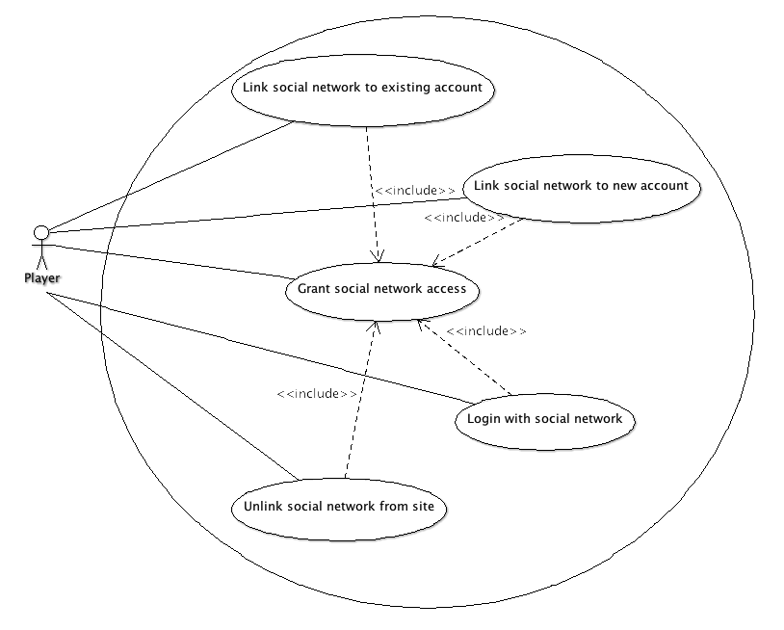

2.2 Friend Management

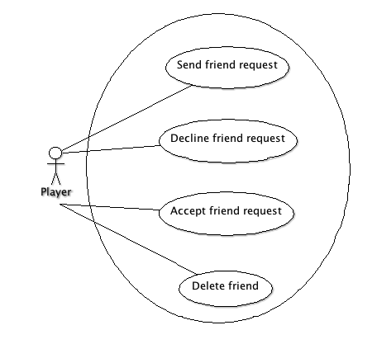

Appendix 3: Class Diagram
